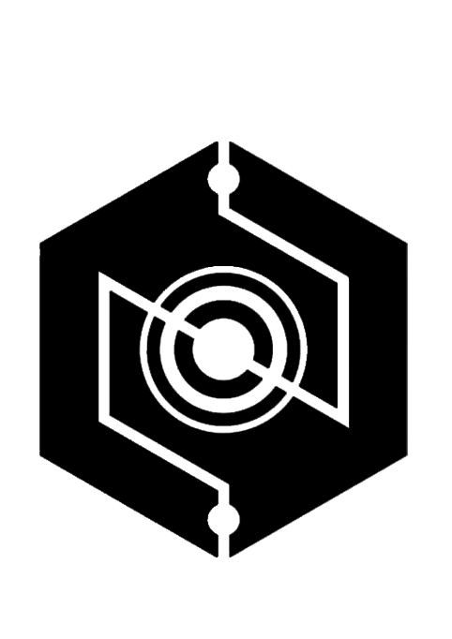 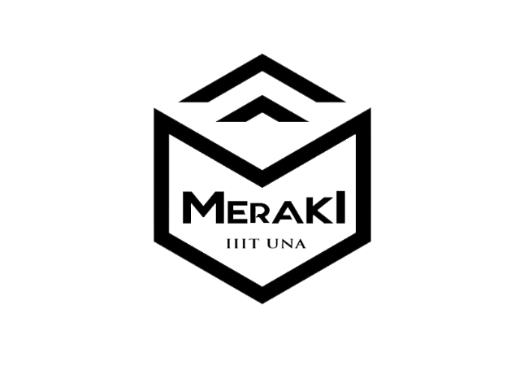

**NIMBUS MERAKI**

**( FESTNIMBUS.COM ) (**[iiitu-meraki.github.io/](https://iiitu-meraki.github.io/))

Since IIIT UNA classes are also being held at NIT HAMIRPUR , both the fests were organised together.

**NIMBUS** is the annual technical festival of National Institute of Technology, Hamirpur, Himachal Pradesh, India. It is touted to be an amalgamation of ideas, expressions, innovations,prototypes, knowledge channels, taken to the most premier levels. In NIMBUS all the departmental teams compete with their best projects, demonstrations and Events. Students from himachal and outside himachal Pradesh come to participate in these events. The team which participates in NIMBUS are

* OJAS (Electrical Engg)
* MEDEXTROUS (Mechanical Engg)
* VIBHAV (Electronics & Comm)
* C HELIX (Civil Engg)
* Hermetica (Chemical Engg)
* .EXE (Computer & Sc)
* Design O Crats (Architecture)

**MERAKI** is the annual technical festival of Indian Institute Of Information Technology,Una,Himachal Pradesh,India. It is a fest of creativity, love and the soul. This year,i.e.2109 FEST MERAKI is organised first time. The team which participates in MERAKI are

* FORCE (Computer & sc)
* TEAM HASH (Computer & Sc)
* IMPRESSIONS (PHOTOGRAPHY)
* AAVESH (Electronics & Comm)
* AMOGH(Magzine)
* INFOSEC
* EVMAC
* SURGE
* DATASCIENCE CLUB

**PRE-NIMBUS FESTS:**

These fests are organised to train the first year student and therefore they can perform to their full potential. The pre-nimbus fests are

1. PRODYOGIKI
2. SPEC-FEST
3. DRAVYA
4. SYGNET
5. SFT
6. HEURISTICS